**Electric Resistance Heating**

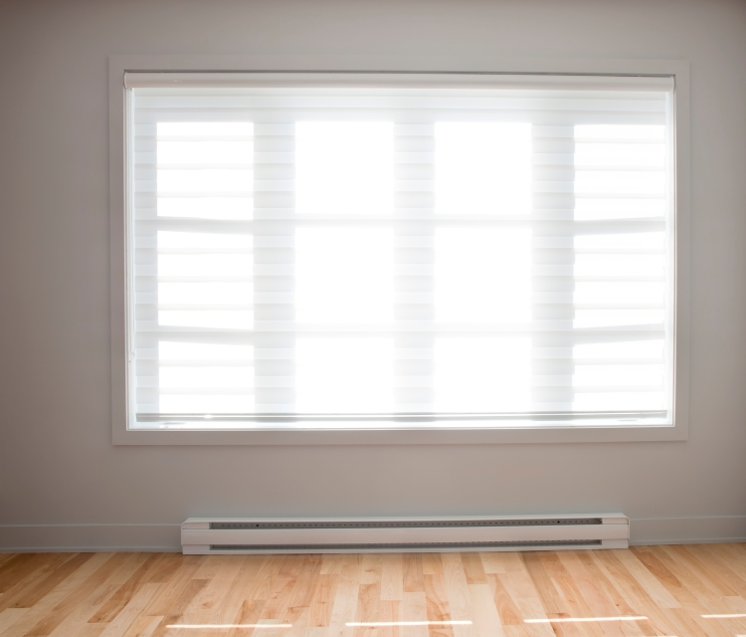

Baseboard heaters are one type of electric resistance heaters. | Photo courtesy of ©iStockphoto/drewhadley

Electric resistance heating is 100% energy efficient in the sense that all the incoming electric energy is converted to heat. However, most electricity is produced from coal, gas, or oil generators that convert only about 30% of the fuel's energy into electricity. Because of electricity generation and transmission losses, electric heat is often more expensive than heat produced in homes or businesses that use combustion appliances, such as natural gas, propane, and oil furnaces.

If electricity is the only choice, heat pumps are preferable in most climates, as they easily cut electricity use by 50% when compared with electric resistance heating. The exception is in dry climates with either hot or mixed (hot and cold) temperatures (these climates are found in the non-coastal, non-mountainous part of California; the southern tip of Nevada; the southwest corner of Utah; southern and western Arizona; southern and eastern New Mexico; the southeast corner of Colorado; and western Texas). For these dry climates, there are so few heating days that the high cost of heating is not economically significant.

Electric resistance heating may also make sense for a home addition if it is not practical to extend the existing heating system to supply heat to the new addition.

Types of Electric Resistance Heaters

Electric resistance heat can be supplied by centralized forced-air electric furnaces or by heaters in each room. Room heaters can consist of electric baseboard heaters, electric wall heaters, electric radiant heat, or electric space heaters. It is also possible to use electric thermal storage systems to avoid heating during times of peak power demand.

Electric Furnaces

Electric furnaces are more expensive to operate than other electric resistance systems because of their duct heat losses and the extra energy required to distribute the heated air throughout your home (which is common for any heating system that uses ducts for distribution). Heated air is delivered throughout the home through supply ducts and returned to the furnace through return ducts. If these ducts run through unheated areas, they lose some of their heat through air leakage as well as heat radiation and convection from the duct's surface.

Blowers (large fans) in electric furnaces move air over a group of three to seven electric resistance coils, called elements, each of which are typically rated at five kilowatts. The furnace's heating elements activate in stages to avoid overloading the home's electrical system. A built-in thermostat called a limit controller prevents overheating. This limit controller may shut the furnace off if the blower fails or if a dirty filter is blocking the airflow.

As with any furnace, it's important to clean or replace the furnace filters as recommended by the manufacturer, in order to keep the system operating at top efficiency.

Electric Baseboard Heaters

Electric baseboard heaters are zonal heaters controlled by thermostats located within each room. Baseboard heaters contain electric heating elements encased in metal pipes. The pipes, surrounded by aluminum fins to aid heat transfer, run the length of the baseboard heater's housing, or cabinet. As air within the heater is warmed, it rises into the room, and cooler air is drawn into the bottom of the heater. Some heat is also radiated from the pipe, fins, and housing.

Baseboard heaters are usually installed underneath windows. There, the heater's rising warm air counteracts falling cool air from the cold window glass. Baseboard heaters are seldom located on interior walls because standard heating practice is to supply heat at the home's perimeter, where the greatest heat loss occurs.

Baseboard heaters should sit at least three-quarters of an inch (1.9 centimeters) above the floor or carpet. This is to allow the cooler air on the floor to flow under and through the radiator fins so it can be heated. The heater should also fit tightly to the wall to prevent the warm air from convecting behind it and streaking the wall with dust particles.

The quality of baseboard heaters varies considerably. Cheaper models can be noisy and often give poor temperature control. Look for labels from Underwriter's Laboratories (UL) and the National Electrical Manufacturer's Association (NEMA). Compare warranties of the different models you are considering.

Electric Wall Heaters

Electric wall heaters consist of an electric element with a reflector behind it to reflect heat into the room and usually a fan to move air through the heater. They are usually installed on interior walls because installing them in an exterior wall makes that wall difficult to insulate.

Electric Thermal Storage

Some electric utilities structure their rates in a way similar to telephone companies and charge more for electricity during the day and less at night. They do this in an attempt to reduce their "peak" demand.

If you are a customer of such a utility, you may be able to benefit from a heating system that stores electric heat during nighttime hours when rates are lower. This is called an electric thermal storage heater, and while it does not save energy, it can save you money because you can take advantage of these lower rates.

The most common type of electric thermal storage heater is a resistance heater with elements encased in heat-storing ceramic. Central furnaces incorporating ceramic block are also available, although they are not as common as room heaters. Storing electrically heated hot water in an insulated storage tank is another thermal storage option.

Some storage systems attempt to use the ground underneath homes for thermal storage of heat from electric resistance cables. However, this requires painstaking installation of insulation underneath concrete slabs and all around the heating elements to minimize major heat losses to the earth. Ground storage also makes it difficult for thermostats to control indoor temperatures.

Any type of energy storage systems suffers some energy loss. If you intend to pursue an electric thermal storage system, it would be best for the system to be located within the conditioned space of your home, so that any heat lost from the system actually heats your home, rather than escaping to the outdoors. It would also be best to know how quickly heat will escape from the system. A system that leaks too much heat could cause control problems, such as the accidental overheating of your home.

Control Systems

All types of electric resistance heating are controlled through some type of thermostat. Baseboard heaters often use a line-voltage thermostat (the thermostat directly controls the power supplied to the heating device), while other devices use low-voltage thermostats (the thermostat uses a relay to turn the device on and off). Line-voltage thermostats can be built into the baseboard heater, but then they often don't sense the room temperature accurately. It's best to instead use a remote line-voltage or low-voltage thermostat installed on an interior wall. Both line-voltage and low-voltage thermostats are available as programmable thermostats for automatically setting back the temperature at night or while you're away.

Baseboard heaters supply heat to each room individually, so they are ideally suited to zone heating, which involves heating the occupied rooms in your home while allowing unoccupied area (such as empty guest rooms or seldom-used rooms) to remain cooler. Zone heating can produce energy savings of more than 20% compared to heating both occupied and unoccupied areas of your house.

Zone heating is most effective when the cooler portions of your home are insulated from the heated portions, allowing the different zones to truly operate independently. Note that the cooler parts of your home still need to be heated to well above freezing to avoid freezing pipes.

From：https://www.energy.gov/energysaver/home-heating-systems/electric-resistance-heating